1.Code:
public class Student {
float CGPA;
public static void main(String[] args) {
Student s1=new Student();
Student s2=new Student();
s1.CGPA=4;
s2.CGPA=4;
System.out.println("Before update: ");
System.out.println(s1.CGPA);
System.out.println(s2.CGPA);
s1.CGPA=3.79f;
System.out.println("After update: ");
System.out.println(s1.CGPA);
System.out.println(s2.CGPA);
}
}
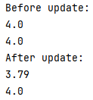
Output:

2.Code:
public class BankAccount {
private int accountNumber;
private double balance;
void input(int accountNumber, double balance) {
if (accountNumber < 0 || balance < 0) {
System.out.println("Invalid Input\n");
} else {
this.accountNumber = accountNumber;
this.balance = balance;
System.out.println("Account number " + accountNumber + " has been created");
System.out.println("Account balance " + balance + "\n");
}
}
}
class BankA{
public static void main(String[] args) {
BankAccount a1=new BankAccount();
a1.input(1,10);
BankAccount a2=new BankAccount();
a2.input(2,20);
BankAccount a3=new BankAccount();
a3.input(3,-130);
}
}
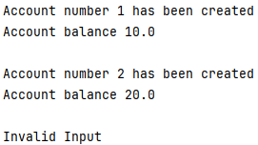
Output:

3.Code:
public class Person {
String name;
int age;
void display() {
System.out.println("Name : " + name);
System.out.println("Age : " + age);
}
}
class Student extends Person{
int studentID;
@Override
void display() {
System.out.println("Student ID : " + studentID);
super.display();
}
}
class Person1{
public static void main(String[] args) {
Student s = new Student();
s.age = 20;
s.studentID = 1;
s.name = "John";
s.display();
}
}
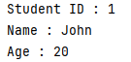
Output:

4.Code:
//Access from same class
package origin;
public class Combo {
int id=1;
private float Balance=1;
public String name="S";
protected int age=1;
void display(){
System.out.println("Name: "+name);
System.out.println("Age: "+age);
System.out.println("Balance: "+Balance);
System.out.println("ID: "+id);
}
}
class Combo1{
public static void main(String[] args) {
Combo c = new Combo();
c.display();
}
}

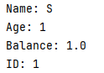
Output:

//Access from other class in same package
package origin;
class A{
}
public class second {
public static void main(String[] args) {
A a = new A();
System.out.println("Name: "+a.name);
System.out.println("Age: "+a.age);
System.out.println("Balance: "+a.Balance);
System.out.println("ID: "+a.id);
}
}
Output:
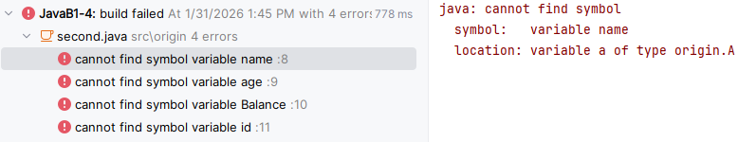
//Access from other class in other package
package other;
public class Opac {
public static void main(String[] args) {
Opac o=new Opac();
System.out.println("Name: "+o.name);
System.out.println("Age: "+o.age);
System.out.println("Balance: "+o.Balance);
System.out.println("ID: "+o.id);
}
}
Output:
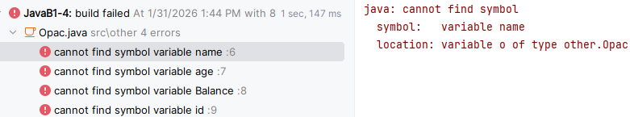

5.Code:
class Person{
private String name;
private int age;
public void setName(String n){name=n;}
public void setAge(int a){
if(a>0) age=a;
else System.out.println("Invalid age!");
}
public String getName(){return name;}
public int getAge(){return age;}
public void displayInfo(){
System.out.println("Person Name: "+name);
System.out.println("Person Age: "+age);
}
}
class Teacher extends Person{
private String subject;
public void setSubject(String sub){subject=sub;}
public String getSubject(){return subject;}
@Override
public void displayInfo(){super.displayInfo();
System.out.println("Teaching Subject: "+subject);}
}
class UniversitySystem{
public static void main(String[] args){
Teacher t1=new Teacher();
t1.setName("Dr. Rahman");
t1.setAge(40);
t1.setSubject("Computer Science");
System.out.println("Teacher Details:");
t1.displayInfo();
// Direct access causes error
// t1.name="Some Name";
// t1.age=50;
}
}
Output:
